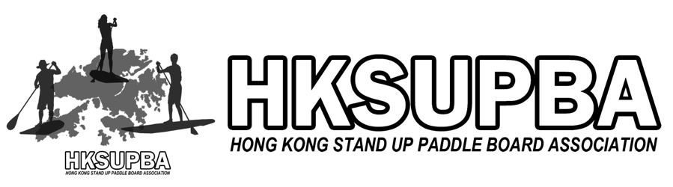
電話：3502 1823 網頁：www.hksupba.com 地址：G/F 26C, Monterey Place, 23 Tong Chun Street, Tseung Kwan O, Hong Kong

Member Notices

We are pleased to announce that HKSUPBA delivers the ISA-INTERNATIONAL SURFING ASSOCIATION Level 1 SUP coach in (a) March 28-29, 2020 (b) June 6-7, 2020 (c) November 7-8, 2020. This course is designed to impart professional coaching skills, safety knowledge and paddle abilities for our local SUP coach and those who would like to join the SUP coaching group. The objective of the course is to improve the safety and efficacy of SUP instruction. This course is accredited by the ISA and recognized throughout the World.

HKSUPBA is the only organization recognized by the International Surfing Association (ISA) in Hong Kong. We do not only focus on SUP event and training athletes but also look forward to improve coaches’ qualification.

We would like to invite you to join our ISA Level 1 coach training course, and together we help SUP to become more popular and all coaches become more professional in Hong Kong.

ISA Level 1 coach Training Course

Date： | - Choose one only  (a) March 28-29, 2020 (Sat, Sun)  (b) June 6-7, 2020 (Sat, Sun)  (c) November 7-8, 2020 (Sat, Sun)
Course Fee ： | - HK$4,000 per person (Early Bird Registration discount before 10 March)  Original: HKD $4500
Venue： | - Sai Kung (theory lesson), Sai Kung (practical lesson)
Requirement | - Can swim at least 50m without any helping equipment  - Can complete 6km within one hour by using SUP in a stand up position  - Holding a valid Life Saving certificate (Bronze Medallion / Beach Lifeguard Award)
Course content： | - Role of the instructor  - Safety of the paddler in your care  - Equipment for the beginning SUP rider  - Instructing method  - Skill development  - Program planning
Test Criteria： | - Venue analysis assessment  - Lesson Planning assessment  - Lesson delivery assessment  - SUP skill assessment  - Post course checklist
Award of Certificate： | - Certificate will be awarded to those who have attended lectures with satisfactory performances and also:  - Complete evaluation and written homework.  - Paid ISA annual fee.  - Finish 20 hours of supervisory coach training course within one year.

Lecturer Review
Bryan NG Yu Fung

Based in: Sai Kung, Hong Kong
Nationality: Hong Kong
Years of SUP: 9
Languages: English, Chinese
Qualification: UNIVERSITY OF BAPTIST – Professional Development Certificate in Fitness Instruction
Hong Kong Coaching Committee (HKCO) - Joint committee of the Hong Kong Sports Institute and the Sports Federation & Olympic Committee of Hong Kong, China
HK ST. JOHN AMBULANCE – First Aid
電話：3502 1823 網頁：www.hksupba.com 地址：G/F 26C, Monterey Place, 23 Tong Chun Street, Tseung Kwan O, Hong Kong

Specialty Degrees: Official course presenter for the International Surfing Association (ISA). ISA Level 1 surf and Flat Water SUP.

Current role: Chairman, Chief Instructor, Chief Judge in HKSUPBA
Head coach and Team manager of Hong Kong Training Team

Media Appearance: Bryan had been participated difference media and magazine access in last few years. He was the SUP and Dragon boat Instructor or Judge in the TV Show.

Enrolment form

Personal Detail
Name
Gender
D.O.B
Occupation（Optional）:
Lesson Date (Choose 1 only): | (a) March 28-29, 2020 (b) June 6-7, 2020 (c) November 7-8, 2020
Contact Detail
Phone：
Address：
Facebook（Optional）：
Emergency Contact Person
Name:
Phone:
Do you have any allergies, medical condition or physical limitations that our instructors should be aware of? If so, please indicate. (Compulsory)
SUP experience
How long have you been playing SUP?
How often do you SUP?
Please share your thought and recommendations for the future SUP development in Hong Kong.

Closing date for application: 14 Days before the lesson day

Payment method:
Bank Deposit: Please deposit or transfer the application fees to HKSUPBA’s account, below please find the details
Beneficiary Name: Hong Kong Stand Up Paddle Board Association Limited
Bank of China (Hong Kong) Limited:
Account No. HKD: (012-818-1-022092-5), other currency: (012-818-9-214462-1)
If you have any questions please contact us at 3502-1823 or email enrollment@hksupba.com.

